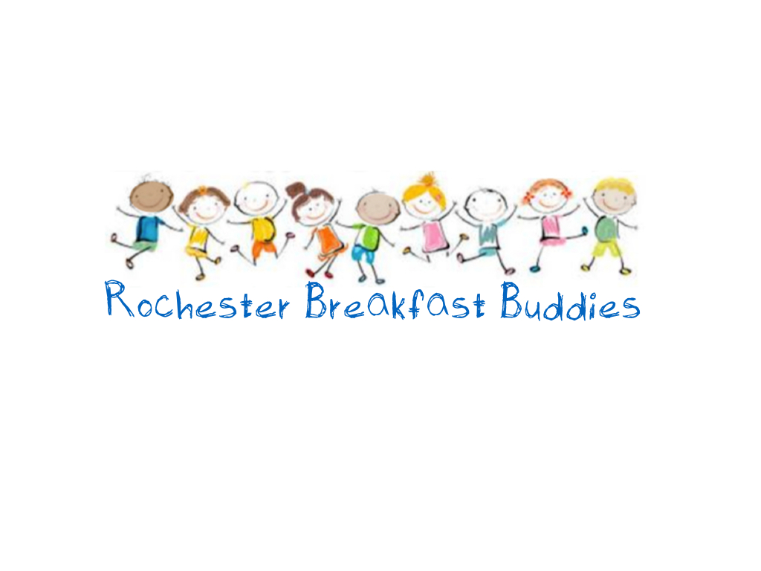
PLEASE NOTE BREAKFAST BUDDIES PROGRAM
LAST DAY WILL BE
DEC. 17 AND RE-OPENING JAN 13, 2020.

Monday, Tuesday & Thursday: 8:00 am – 8:45 am

**Please note breakfast will only be served until 8:45 to allow for clean up and use of the gym by the 9am class.**

